Ratan Tata, the beloved industrialist and former chairman of Tata Sons, passed away on 9th October 2024, leaving an indelible mark on the hearts of millions. After spending decades steering India’s biggest business empire, Tata continued to inspire people with his humility, curiosity, and zest for life. Even in his later years, he was learning to play the piano at 85—a testament to his never-ending thirst for new experiences. It’s these small glimpses into Tata’s life that inspired millions, proving that age really is just a number.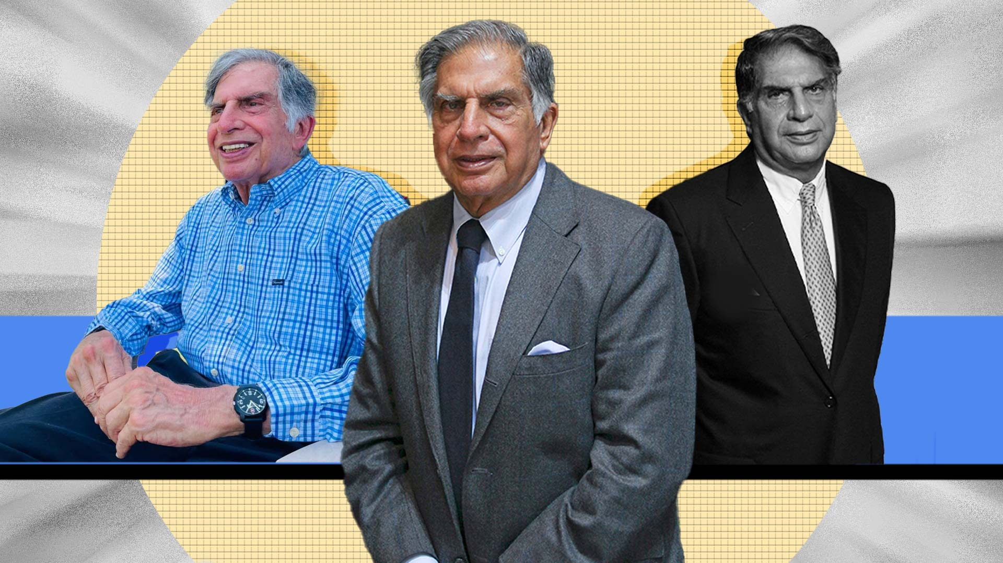

A quick scan through the [business tycoon’s](https://www.gqindia.com/topics/ratan-tata) Instagram page will reveal that Tata possessed the same childlike curiosity and sincerity that helped him turn Tata Group from a predominantly India-centric group into a booming global business worth Rs. 9.6 trillion ($128 billion) in 2021-2022. His posts reveal his love for dogs, his passion for cars and jets, and even his playful side, as he embraced trends like ‘Throwback Thursdays’ and shared memories with fans. He once called Guns N’ Roses guitarist Slash “a very polite rockstar”—showing off his cool, candid humour.

The only hint of his age was perhaps his penchant for writing Instagram captions that felt like entries straight out of a family photo album. But that’s exactly what made him so relatable and authentic, adding to his charm and making him all the more beloved. This genuine warmth turned him into a social media sensation, with 12.4 million Twitter followers who cherished every post he shared. It’s this blend of brilliance, authenticity, and childlike wonder that we’ll remember and celebrate forever.

**Family**

It was natural to assume that a legacy as rich as the Tata family’s would continue through the generations. However, Ratan Tata never married, despite coming close several times, as he shared in a series of recent interviews. In a post for Humans of Bombay, he recounted how, during his time working at an architecture firm in Los Angeles, he fell in love with a girl. However, due to his grandmother's declining health, he made the difficult decision to return to India, while she chose to stay behind. And that was the end of that chapter.

His choice to prioritize his grandmother was entirely in line with his values. Ratan Tata was born on December 28, 1937, to Naval and Sonu Tata. However, after his parents separated and his father remarried (to Simone Tata), his grandmother, Navajbai Tata, took him in and formally adopted him.

In the 1970s, Ratan Tata was given a managerial position in the Tata group. He achieved initial success by turning the subsidiary National Radio and Electronics (NELCO) around, only to see it collapse during an economic slowdown.[[25]](https://en.wikipedia.org/wiki/Ratan_Tata#cite_note-BS-26)[[26]](https://en.wikipedia.org/wiki/Ratan_Tata#cite_note-27) In 1991, [J. R. D. Tata](https://en.wikipedia.org/wiki/J._R._D._Tata) stepped down as chairman of Tata Sons, naming him his successor. Initially, Tata faced stiff resistance from the heads of various subsidiaries, who had a large amount of operational freedom under the senior Tata's tenure. In response, Tata implemented a number of policies designed to consolidate power, including the implementation of a retirement age, having subsidiaries report directly to the group office, and requiring subsidiaries to contribute their profit to building the Tata group brand. Tata prioritised innovation and delegated many responsibilities to younger talent.[[27]](https://en.wikipedia.org/wiki/Ratan_Tata#cite_note-ChrisDeresky-28) Under his leadership, overlapping operations between subsidiaries were streamlined into company-wide operations, with the group exiting unrelated businesses to take on globalisation.[[28]](https://en.wikipedia.org/wiki/Ratan_Tata#cite_note-29)

Ratan meets union minister [Anand Sharma](https://en.wikipedia.org/wiki/Anand_Sharma" \o "Anand Sharma) in 2011

During the 21 years Tata led the Tata Group, revenue grew over 40 times, and profit over 50 times.[[25]](https://en.wikipedia.org/wiki/Ratan_Tata#cite_note-BS-26) When he took over the company, sales overwhelmingly comprised commodity sales, but at the end of his tenure, the majority of sales came from brands.[[29]](https://en.wikipedia.org/wiki/Ratan_Tata#cite_note-30)[[30]](https://en.wikipedia.org/wiki/Ratan_Tata#cite_note-31) He had [Tata Tea](https://en.wikipedia.org/wiki/Tata_Global_Beverages) acquire [Tetley](https://en.wikipedia.org/wiki/Tetley), [Tata Motors](https://en.wikipedia.org/wiki/Tata_Motors) acquire [Jaguar Land Rover](https://en.wikipedia.org/wiki/Jaguar_Land_Rover), and [Tata Steel](https://en.wikipedia.org/wiki/Tata_Steel) acquire [Corus](https://en.wikipedia.org/wiki/Corus_Group_plc). These acquisitions repositioned Tata from a largely India-centric group into a global business, with over 65% of revenues coming from operations and sales internationally.[[25]](https://en.wikipedia.org/wiki/Ratan_Tata#cite_note-BS-26)

He also conceptualised and spearheaded the development of the [Tata Nano](https://en.wikipedia.org/wiki/Tata_Nano) car after the grand success of Diesel [Tata Indica](https://en.wikipedia.org/wiki/Tata_Indica), which helped put cars at a price-point within reach of the average Indian consumer.[[31]](https://en.wikipedia.org/wiki/Ratan_Tata#cite_note-32)[[27]](https://en.wikipedia.org/wiki/Ratan_Tata#cite_note-ChrisDeresky-28) [Tata Motors](https://en.wikipedia.org/wiki/Tata_Motors) has since rolled out the first batch of Tigor Electric Vehicles from its [Sanand Plant](https://en.wikipedia.org/wiki/Sanand_Plant_(Tata_Motors)" \o "Sanand Plant (Tata Motors)) in Gujarat, which Tata has described as to "fast-forward India's electric dream."[[32]](https://en.wikipedia.org/wiki/Ratan_Tata#cite_note-33)

Upon turning 75, Ratan Tata resigned his executive powers in the Tata group on 28 December 2012. An ensuing leadership crisis over his succession drew intense media scrutiny.[[33]](https://en.wikipedia.org/wiki/Ratan_Tata#cite_note-34) The board of directors of the company appointed his successor, [Cyrus Mistry](https://en.wikipedia.org/wiki/Cyrus_Mistry), a relative of Tata and the son of Pallonji Mistry of the Shapoorji Pallonji Group, which was the largest individual shareholder of the Tata group.[[34]](https://en.wikipedia.org/wiki/Ratan_Tata#cite_note-35)[[35]](https://en.wikipedia.org/wiki/Ratan_Tata#cite_note-36) On 24 October 2016, Cyrus Mistry was removed as chairman of Tata Sons, and Ratan Tata was made interim chairman. A selection committee, which included Tata as a member, was formed to find a successor.[[36]](https://en.wikipedia.org/wiki/Ratan_Tata#cite_note-37) On 12 January 2017, [Natarajan Chandrasekaran](https://en.wikipedia.org/wiki/Natarajan_Chandrasekaran) was named as the chairman of Tata Sons, a role he assumed in February 2017. In February 2017, Mistry was removed as a director for Tata Sons.[[37]](https://en.wikipedia.org/wiki/Ratan_Tata#cite_note-:0-38) The [National Company Law Appellate Tribunal](https://en.wikipedia.org/wiki/National_Company_Law_Appellate_Tribunal) later found in December 2019 that the removal of Cyrus Mistry as the chairman of Tata Sons was illegal, and ordered that he be reinstated.[[37]](https://en.wikipedia.org/wiki/Ratan_Tata#cite_note-:0-38) On appeal, India's Supreme Court upheld the dismissal ofCyrus Mistry .

